**Pearson**

**Higher Nationals in**

**Computing**

Unit 13: Computing Research Project

Project Proposal

**The challenges of work from home during social distancing time in the pandemic situation.**

By

**S. Vakshalan**

**<Pearson ID>**

Submitted in accordance with the requirements for the  
**COMPUTING RESEARCH PROJECT MODULE OF PEARSON’S HND IN < YOUR STREAM> PROGRAMME**  
at the  
**ESOFT METRO CAMPUS**

**Name of research Tutor: <Tutor’s Name>**

**<Date>**

# DECLARATION

Name of Research Candidate:

Pearson Registration Number:

Programme Name:

Research Title:

Field of Study:

I do solemnly and sincerely declare that:

* 1. I’m the sole author of this study
  2. This work is original
  3. In case of any use if any information from other sources references of copyright with its ownership have been acknowledged in this document
  4. I do not have any actual knowledge nor do I ought reasonably to know that the making of the work constitutes an infringement of any copyright work
  5. I know that plagiarism is a punishable offence because it constitutes theft, I understand the plagiarism and copying policy of the Edexcel UK, I know what the consequences will be if I plagiaries or copy another’s work in this research for this program.

Candidate Signature: ……………………. Date: ……………………….

Subscribed and solemnly declared before,

Supervisor’s Name: ………………………………………………………………………

Designation: …………………………………..

Supervisor’s Signature: ……………………. Date: ………………………..

**Abstract**

Due to the covid 19 pandemic situation most of the companies recommended to the employees to do their work in online method. Regarding the unforeseen situation it was a big challenge to maintain the productivity in online method as same level as working in the office and it was hard thing to train the employees to work with the online method. At the beginning of the pandemic situation, most of the employees who had not much computer knowledge or modern technology knowledge have faced so may difficulties of adopting to use online tools. Moreover, they couldn’t manage their working hours with their daily routines. With this paper outlines a survey conducted amongst employees who are working from home to identify the challenges this change in workstyle offers. However, according to the survey, the final results show us that within a small amount of period the employees could be able to managed their own work and develop the necessary knowledge and skills for working remotely. Nevertheless, we could be able to identify that how they manage the digital tools, collaborating with other employees in online platforms, the problems they have faceted and how they could manage workload when using online tools. Most of the employees recognized the advantage of remote working as same as the negative impacts of it. Likewise, within the context of this paper it is discussed about the challenges of work from home during social distancing time in the pandemic situation.

**List of figures**

Figure 1.1 Management Views on Working from Home 7

Figure 1.2 Challenges of remote working 8

Figure 1.3 Struggling with working remotely 9

Figure 1.4 Software’s that Using for online communication 10

Figure 1.5 Reasons for software selection 11

Figure 4.1 recognized problems of companies 18

Figure 4.2 Challenges of remote working 18

**List of tables**

Table 3.1Comparison between former researches with proposed research 16

**Table of Contents**

**Topic** ................................................................................................................................... 2

**Declaration**.......................................................................................................................... 3

**Abstract**............................................................................................................................... 4

List of figures ...................................................................................................................... 5

List of tables......................................................................................................................... 5

1. **Introduction** ................................................................................................................. 7
2. **Background & Literature Survey** ............................................................................ 13
3. **Research Gap**.............................................................................................................. 15
4. **Research Problem**....................................................................................................... 17
5. **Objectives**.................................................................................................................... 19

5.1. Main Objective ..................................................................................................... 19

1. **Methodology**................................................................................................................ 20
2. **References**................................................................................................................... 22

**1.Introduction**

In near 2019 not only in China but also all over the world have faced a huge problem called COVID-19 pandemic. As we know, the COVID-19 pandemic situation has been without a doubt exacerbated mainly in economic and social challenges across all the countries. Most of the people died because of this pandemic. Regarding this situation mainly companies, were faced so many problems by maintain their work. It was a huge challenge to maintain their productivity as same as in this pandemic situation and they need to be connected with customers to do to succeed their work.

Therefore, due to the covid 19 pandemic situation most of the companies need the employees to do their work with connecting with each other and maintain their productivity. They thought to change the nature of the work. They have recommended that work form home because the whole country needs to face that problem as much as they can (“Ovidius” University Annals, 2020). So that as the result the found a solution that to connecting with others and maintain their productivity by working remotely.

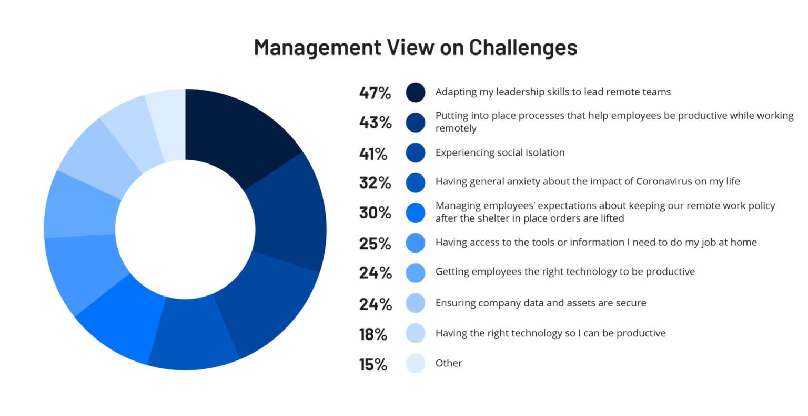

Figure 1.1: Management Views on Working from Home

Acoording to our servey we asked that both companies and the workers that what are the challenges they have faceed durng working remotely. Regarding the pie chart below, more that 40% of company owners have struggled mostly with adapting how to lead a remote workforce with the workers who had never working remotely before (Bluescape, 2020). However we could be able to analize all the problems that are facing by the companies regarding to this COVID-19 pandemic situation.

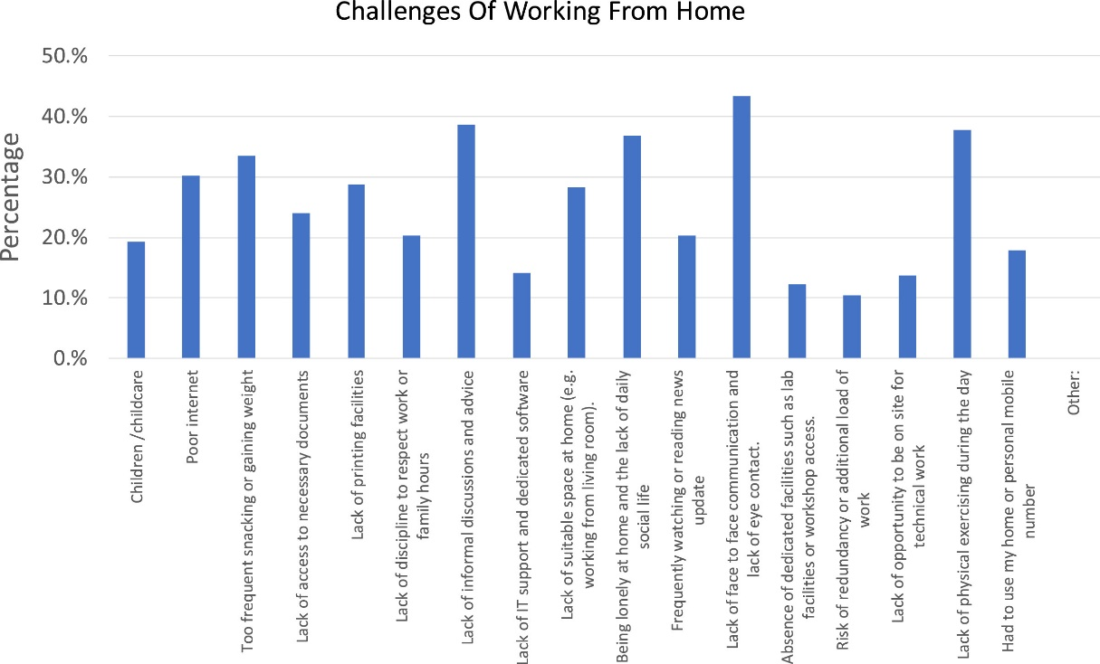

Figure 1.2: Challenges of remote working

According to the diagram that, we could be seen that the challenges that the workers have faces during the pandemic situation (Market Insights, Growth & Productivity, 2020). As the employees it was hard to practice working remotely because most of them were never have any experience of working from home previously. However, all must to face that problem as this is global pandemic situation. In that case the companies need to help the employees t train their employees for working remotely by using digital tools and keep the connectivity with each other.

Most of the developed counties have already used the online digital tool for do their task easily (JMIR Public Health Surveill., n.d.). So that they did not face more difficulties than others, but the developing countries and non-developed countries have faced so many difficulties when using online digital tools in working from home. Regarding this issue most of the companies should have been appointed some team to train who are that the beginners for online digital tools. It was a kind of a risk that they have taken on their entire working life because, they were never experienced the results of that. However, they take the risk and train all of the employees for working by using online methods and keep the connectivity with each other. The bellow pie chart clearly shows that (NAN JIANG and JULIE RYAN, 2020).

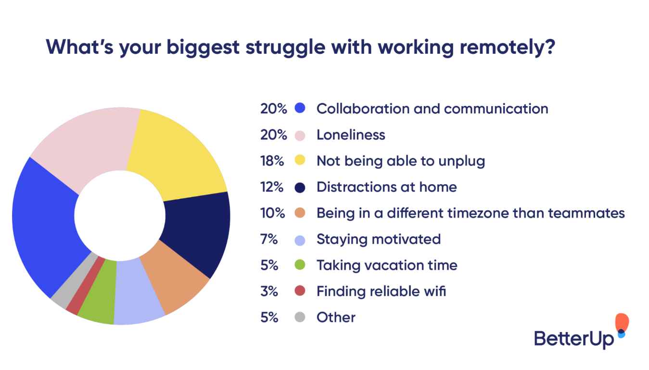

Figure 1.3: Struggling with working remotely

However according to this one we could be able to list down that what was the mostly effect the to the remote workers that 20% are struggling of collaboration and communicating with others and another 20% of workers struggling of the loneliness (fireflies.ai, 2021).

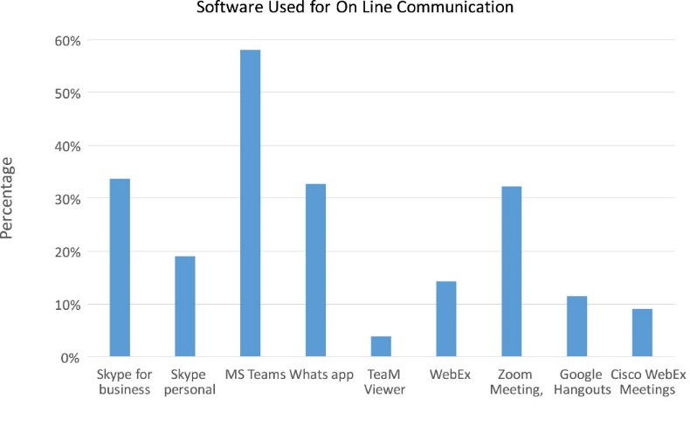

Figure 1.4: Software’s that Using for online communication

In here we could be able to know what are the software that can be use for online communication and to know what are the most useful software that the people are used to do their work with electronic devices. Regarding this we could be able to identify what was the most famous platform, least used software platforms as well (International Journal of Information Management, 2020).

Therefor according to the bar chart in here we could identify that most of the users like more than 58% of use **MS teams** as for communicate and do working from home (International Journal of Information Management, 2020). As same as near to 30% of users use **Skype for business, WhatsApp** and **Zoom meeting** platforms on their working period. Apart from that most famous software’s that are using

* Skype for personal
* WebEx
* TeaMViewer
* Google Hangouts
* Google meet
* Cisco WebEx Meetings

And also, we could be able to identify that how the employees were manage the digital tools, collaborating with other employees in online platforms. As mentioned before people have never faced this kind of a pandemic situation and most of employees never tried to work form home rather than go to the site and work. It was a huge difficulty to most of the employees who do not have any experience with working with online tools. As same as it was some kind of a new experience for them. According to the issue the companies should have to start giving a full training period for all of the employees who do not have much knowledge of using electronic devices and who need to be connected with the company in working hours. Having less than three months of a good training, the employees could be able to work by using online digital tools. After the training there were able to familiar with the electronic devises, digital tools and work from home (International Journal of Information Management, 2020).

For communicate with workers, the companies use so many technologies by researching them. The bellow diagram shows that how the companies selected the technologies for their working platforms and what are the reasons for the software selections.

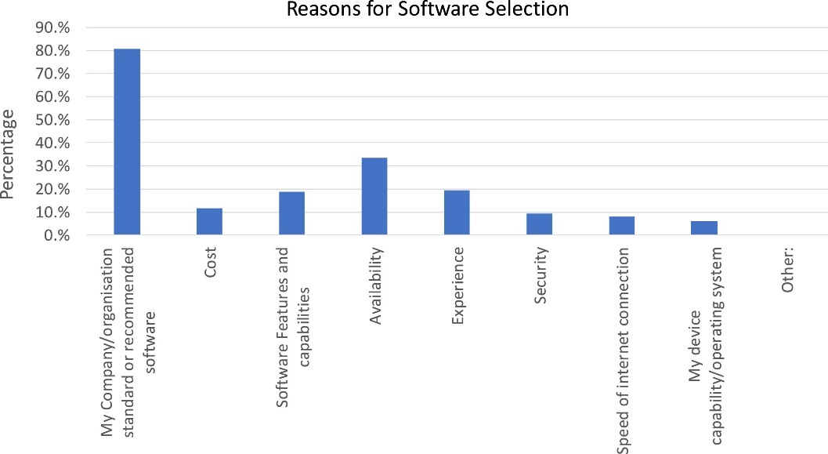

Figure 1.5: Reasons for software selection

However, then another problem was how to find electronic devices like laptops, computers, tablets, smartphones and etc because they need to spend some money for buy them from stalls. Nevertheless, when considering about employees, they need to consider that when more than one person in their family is working remotely, how far if it is possible that each family member is having a committed workspace where they can work without any disturbance. Therefore, the family members should have to arrange some specific places for each and every member for do their work without any disturbances. It was a challenge to some amount of people because they do not have that much space in their houses. As a solution for that problem each and every family has organized and take a plan to overcome that problem by separating places and manage small places for their need.

And the other problem is that most of the workers have struggled due to manage their working time and when the schools and institutes are closed, they need to work around childcare commitments (International Journal of Information Management, 2020). Workers need have some family meetings and then after they reach an agreement on how could be able to fit into their work-from-home schedule.

However, when there were so many challenges to face, the workers could be able to overcome the problems by using general knowledge and after then, they could be able to continue their productivity with making connection with each other. According to the Covid-19 pandemic has provided a unique opportunity to understand the potential for enhanced working from home (“Ovidius” University Annals, 2020).

**2. Background & Literature Survey**

The main purpose of the speech recognition is to find that what was challenges of the working from in the COVID 19 pandemic situation and find the solutions for this situation. Therefore, regarding this pandemic situation mainly most of the countries need to maintain their productivity as same as previous productivity. In that situation people need to continue their connectivity with each other and continue their lifestyle as before starting the pandemic situation.

In last 2020, one research was carried out by the “International Journal of Information Management”. This was aimed to “ Normalising the “new normal”: Changing tech-driven work practices under pandemic time pressure”. According to their research the mainly focuses on the changing nature of the work and the adoption of remote working practices.

On that research they argue that it is very essential for a more reflective ‘normalisation’ of work practices and the role technology plays. In that case it is mainly emphasize that there need to start a little training or otherwise, reflection on how to practice and associated with the technology should be introduced. And also, it recognized that should integrated or else adapted to suit the new workplace context.

As same as previous in last 2020, another research was carried out by the “International Journal of Information Management”. According to their research, they have explored about the impact of the Covid-19 pandemic on technology and innovation management research. They have identified the key assumptions mainly and then; they have discussed about how new areas of investigations are emerge based on the changed reality. And also, they have discussed that social contagion, digital transformation and speed of adoption as well. Therefore, they could be able to find how the pandemic situation was mainly impact for workers.

It is careered out “COVID-19, digital privacy, and the social limits on data-focused public health responses” that have published in 2020 by “ELSEVIER”. It is mainly focuses on the development of contact tracing digital applications all over the world by using a special survey. Not only that but also, they focus on the public consciousness of online privacy, personal and national attitudes to privacy. According to the research it is found that, because of the digital contact tracing for COVID-19 remains in its infancy, protection of human and their privacy may already have impeded its capacity to contribute to this pandemic response.

**3. Research Gap**

According to the literature survey above conducted it is evident that it was huge challenge of the working from in the COVID 19 pandemic situation and regarding this pandemic situation mainly all over the countries needs to maintain their productivity as same as previous productivity by working from home by using online digital tools since only few researches has ben done targeting that. Up to now done in the researches which was conducted under some domain specific recognition. Some of them were only focused on very limited area in the domain of COVID 19 pandemic situation and the challenges of working from home. Therefore, according to that researches we could be able to see that the previous researches has bee covered following domains like,

* Economic domain
* Productivity domain
* Education domain
* Employee training methodology
* COVID 19 pandemic situation
* Electronic devices and online tools
* Remotely working methodology

Moreover, there is no any individual research which is covering that all the challenges and opportunities with the solution for the regarding problem. The main purpose of the proposed application is to provide some solutions for companies to recognize challenges about the employees who are working remotely are not much knowledge about using digital tools. Therefore, following given table depict that the important features of some currently done researches and the proposed research very clearly.

Table3.1 *– Comparison between former researches with proposed research*

|  |  |  |  |
| --- | --- | --- | --- |
| *Research* | *Find the challenges* | *Find the opportunities* | *Introduces solution tools* |
| *Research A* | ***Close with solid fill*** | ***Close with solid fill*** | ***Close with solid fill*** |
| *Research B* | **Checkmark with solid fill** | **Checkmark with solid fill** | ***Close with solid fill*** |
| *Research C* | ***Close with solid fill*** | ***Close with solid fill*** | ***Close with solid fill*** |
| *Research D* | ***Close with solid fill*** | ***Close with solid fill*** | ***Close with solid fill*** |
| *Research E* | ***Close with solid fill*** | ***Close with solid fill*** | ***Close with solid fill*** |
| *Proposed Research* | **Checkmark with solid fill** | **Checkmark with solid fill** | **Checkmark with solid fill** |

**4. Research Problem**

In last 2019 we all have faced the COVID 19 pandemic situation as humans. So that, the countries need to maintain their economy continuously as same as before the pandemic. Therefore, they decide the workers that, to work from home (working remotely). According to the Department census and statistics in Sri Lankan in 2017, it is shown that the Sri Lankan computer literacy is about near to 28%. Apart from that population, less than 6.0% of workers population can had the knowledge about computer literacy. As same as the Sri Lanka, the other developing countries are also has face the regarding situation.

However, not only the mentioned developing countries but also all the countries need to maintain their productivity as same as previously. They need to use online digital tools for keep connecting with each other’s and do their task in working remotely. In that situation it was a new experience for most of the workers who have never worked from home before. Nevertheless, it was a big challenge for all the companies to maintain their productivity by keep the connection with the workers. Therefore, companies had to train the workers for working from home by using those digital tools and how to use electronic devices those need to keep the connection with each other.

Apart from that according to the survey, we could be able to recognize the new problems of companies and bellow diagram depict it very clearly.

* The software features and capabilities
* Costs
* Availability
* Experience
* Internet connection speed
* Devices and the operating systems
* Company standards or recommended software’s.

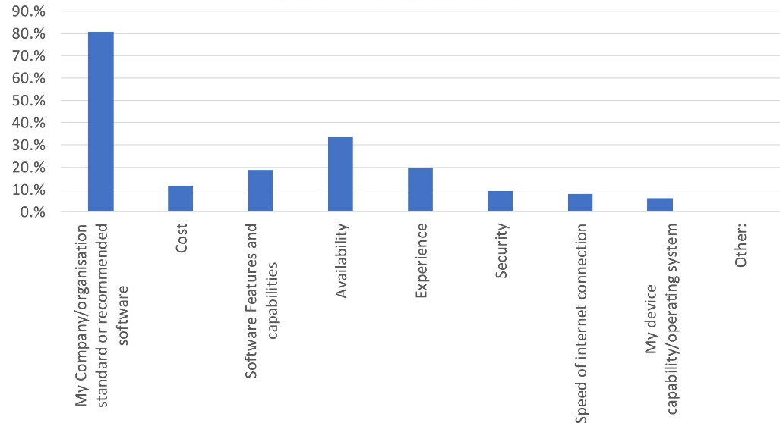

Figure 4.1 recognized problems of companies

According to the survey not only the companies, but also we could be able to recognize the challenges of remote working and bellow diagram emphasize it very clearly.

Figure 4.2: Challenges of remote working

**5. Objectives**

**5.1. Main Objective**

In this research main objective is to recognize that what were the challenges working from which had to be faces during the COVID 19 pandemic situations, find the proper solutions for that. The proposed research not only that but also discussing about that how to be prepare for the future disasters and how to continue the productivity of the entire world with connecting with each other without meeting face to face and using online platforms. By this research it is ability to find out workers side problems as well as the companies side problems. Therefore, by considering about this research, companies and the employees could be able to maintain the productivity of the company without coming to the site but working remotely.

**Methodology**

After having some important sessions with the supervisor to finalize the speech to a text component, the essential requirements were identified. According to this the literature survey and the background of this, it mainly helps the companies and the workers to maintain their productivity when working from home as same as when working onsite. When go through this entire research this may clearly emphasizes that how to recognize the challenges and how to be prepare for any kind of a global problems as well as how to face the challenges form each and every problem that have faced the companies or workers who allocated to work remotely. According to the research the companies need to be prepare for any kind of situation and need to be strong to face, that kind of situations. Nevertheless all must need to fist find he problem and then after take the solutions one bye one as experiments. Then only the company could be ale to face this kind of global problems perfectly.

# References

“Ovidius” University Annals, 2020. *Economic Sciences Series.* [Online]   
Available at: https://stec.univ-ovidius.ro/html/anale/RO/2020/Section%203/35.pdf  
[Accessed 1 January 2020].

Bluescape, 2020. *Bluescape.* [Online]   
Available at: https://www.bluescape.com/blog/5-charts-revealing-management-views-on-working-from-home  
[Accessed 15 June 2020].

fireflies.ai, 2021. *fireflies.ai.* [Online]   
Available at: https://fireflies.ai/blog/remote-work-loneliness  
[Accessed 27 May 2021].

International Journal of Information Management, 2020. *ScienceDirec.* [Online]   
Available at: https://www.sciencedirect.com/science/article/pii/S0268401220308422  
[Accessed Desember 2020].

International Journal of Information Management, 2020. *ScienceDirect.* [Online]   
Available at: https://www.sciencedirect.com/science/article/pii/S0268401220310239  
[Accessed 01 December 2020].

JMIR Public Health Surveill., n.d. *The National Center for Biotechnology Information.* [Online]   
Available at: https://www.ncbi.nlm.nih.gov/pmc/articles/PMC7759507/  
[Accessed 23 December 2020].

Market Insights, Growth & Productivity, 2020. *Wahl and Case.* [Online]   
Available at: https://www.wahlandcase.com/blog/how-to-keep-everyone-motivated-when-working-remotely  
[Accessed 8 May 2020].

NAN JIANG and JULIE RYAN, 2020. *World Bank Blogs.* [Online]   
Available at: https://blogs.worldbank.org/developmenttalk/how-does-digital-technology-help-fight-against-covid-19  
[Accessed 29 May 2020].